**Introduction**

Background -: Corona virus widely known as COVID-19 are a large family of viruses that are known to cause illness ranging from the common cold to more severe diseases such as Middle East Respiratory Syndrome (MERS) and Severe Acute Respiratory Syndrome (SARS).

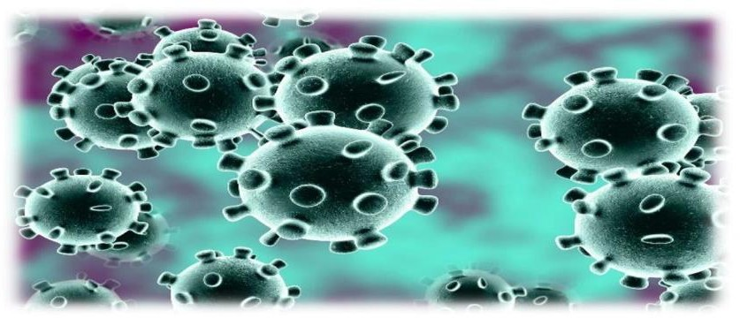

**Figure 1**

The virus out-braked on Nov-2019 from Wuhan city of china. The virus affected south China for about a month and then it spread throughout the world making the path through Europe. The champion‟s league game between Atlanta and Valencia became the poison for spreading the virus in Europe as more than 80,000 spectators were in stadium. Till date, the virus had spread in about 235 territories affecting more than 55 million of population. Nepal also reported its first COVID-19 case on 23 January 2020 which today tallied to 208,299 cases. The timely imposing of the lockdown controlled the chances of rapid incrementation of infected population till June. But with the foreign manpower being brought to home country and loosening of lockdown after July, the number of infected population increased in the exponential way. The large number of people are being infected and killed on daily basis all over the world. And the data of death, infected and recovered cases are being provided on 2 different websites, Google, webpages etc. But these data are only limited to national and international level. Therefore, with the necessity to bring the data of local level with effective analysis, and to make a project work possible through virtual classes we the students of Geomatics engineering were assigned with project “Emergency Handling of COVID-19 in Home countries”. Hence, with the guidelines of supervisors and strong group work, we have finally completed our engineering project. 1.2 Problem Statement With an outbreak of COVID - 19.

**Feasibility Study**

**A feasibility study is simply an assessment of the practicality of a proposed project plan or method**. This is done by analysing technical, economic, legal, operational and time feasibility factors.

The suggested framework is also helpful for patients and doctors in pandemics such as coronavirus disease(COVID-19). Due to the spread of COVID-19, most of the countries imposed sudden lockdown in major cities; as a result, almost ten billion citizens were quarantined. During this pandemic, people put their focus on accumulating more necessary care. Hence, if the proposed framework is applied to the current crisis, it would provide a medical platform that may help patients to receive adequate medical care at homes.

**Methodology/Planning of work**

COVID-19 is a disease caused by a new strain of corona virus. 'CO' stands for corona, 'VI' for virus, and 'D' for disease. Formerly, this disease was referred to as '2019 novel corona virus' or '2019-nCoV.' It was first detected in the Wuhan city located in South China which mend its way to America and throughout the world devastating central Europe. Its effect reached to our country in no time and now there are more than 200,000 cases in the country. The general public of the country have been facing lockdown since last six months and been going through numerous difficulties with lots of fear in their mind. Lots of data have been published nationally but the people are unaware about the situation in their locality. As, we being from all parts of the country are analyzing the situation in our home country so that we could provide some relevant information to the local people. Thus we had picked up this project as emergency handling of covid- 19 in our home districts. There have been Mapathon and thematic competition regarding the presentation and exposing of COVID-19 data by different media. It contributed a lot for researchers like us in completing our project. As the local data were unavailable through the web- pages of governmental offices and we were unable to participate physically in extracting through primary sources these competition help ped us a lot in extracting the un-highlighted data and analyze them in a systematic manner. The Mapathon held by the NGES, contributed us to get the data. There were many participants and they have presented the different Maps showing the COVID-19 Cases of different districts, municipalities and national level data.

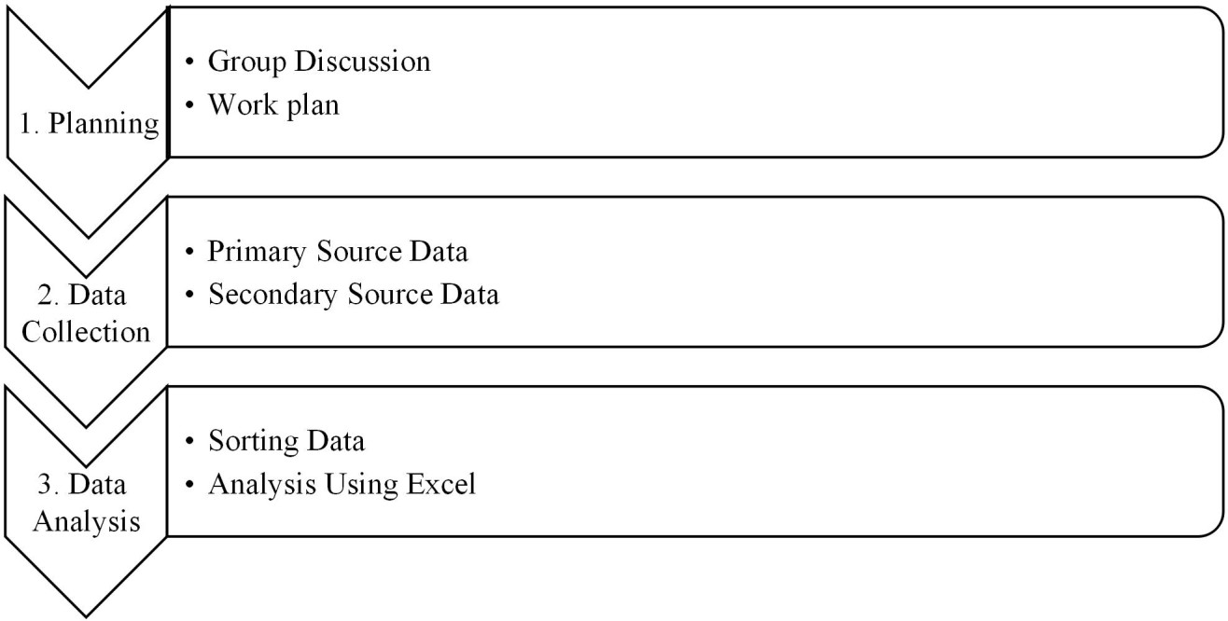

**Problem Description**

Any technology is only as good as the environment that supports it. CTAs will only work if virus tests are available to verify the alerts, if quarantine is possible and if an adequate health infrastructure exists for treatment. Hence, they would be pointless in places like refugee camps, overcrowded worker dormitories or informal settlements.

Developing and using a technology requires investment and time. If the technology is not effective, this poses a serious challenge. The effectiveness of CTAs is dependent upon sufficient and correct usage. It has been calculated that a minimum of 60% uptake is necessary for the effectiveness of CTAs

Some CTAs do not work on smartphones that are older than two years. In addition, false alarms are a serious problem. Bluetooth-based proximity detection carries a risk of over-reporting interactions, leading to ‘a huge number of false positives. False-positives could result in needless self- isolation or might cause users to ignore warnings if they are perceived as unreliable.

**Applications or social benefits of this project:**

* It helps to get updated about corona related information on daily basis.
* It also helps to get corona data from all country by which people who‟s travels in different countries can get status about covid infected cases.

**Planning:**

After getting suggestion and ideas from our project orientation and respective supervisors we did discussion with our group members via Google meet. In our first phase of planning, we share our personal prospective regarding our project, discussed situation of COVID-19 in our home countries, and possible ways to get data like different web-pages, from nearest local level authorities or through different communication channels e. g. Phone, email. Similarly, we planned to do some research and study on different sites so to find an updated, accurate and authorized websites and pages from which we can extract reliable data. In our second phase of planning, we planned the ways to sort the data, analyzed them through different aspects and finally present them in a systematic form.

**Data Collection:**

After some research we found that the website of “Ministry of Health and Population” websites of CDO and DAO Office of individual home districts are the most updated and accurate sites so we have followed this site for most of our data. Similarly, we have visited the nearest local level authorities and communicated via phone and email for local level data. Finally, we collected data on different basis like: Gender wise covid-19 data, Age wise, total infected, total recovered, total death, no of quarantine in our home district and no of PCR and RDT test.

**Data Analysis:**

It was third and the last phase of our project. After collecting the data, as per our planning we prepared the different excel sheet and recorded them. We sorted the collected data and represent those using different visualization method like Bar graph, Pie charts ,Line Charts, columns and analyzed them making comparative study of the COVID -19 situation. Detailed analysis and output is described in the Output Section

**Facilities required for the proposed work**

**SOFTWARE REQUIREMENTS**

Operating System : Window 10

Front End : HTML,CSS,JAVASCRIPT

Framework: React JS

It work on API(**Application programming interface).**

HARDWARE REQUIREMENTS

Machine : Pentium 4

Speed : 233 MHz and above

Hard Disk : 1GB

RAM : 256MB

**Bibliography**

1. <https://stackoverflow.com/>
2. <https://material-ui.com/>
3. <https://reactjs.org/>
4. <https://www.npmjs.com/>
5. <https://www.youtube.com/>